Histopathologic Oral Cancer Detection using Decision Tree and XG Boosting

Vineeth Reddy Maadugula

700742040

Dept: Computer Science

University of Central Missouri

[vxm20400@ucmo.edu](mailto:vxm20400@ucmo.edu)

Preetham Reddy Kesireddy 700741299 Dept: Computer Science University of Central Missouri [pxk12990@ucmo.edu](mailto:pxk12990@ucmo.edu)

Alekhya Reddy Bhimireddy 700724917 Dept: Computer Science University of Central Missouri [axb49170@ucmo.edu](mailto:axb49170@ucmo.edu)

Azargani Dudekula 700726234 Dept: Computer Science University of Central Missouri [axd62340@ucmo.edu](mailto:axd62340@ucmo.edu)

***Abstract*— Oral cancer is the sixth most often diagnosed head and neck cancer, with the bulk of cases occurring in south Asian nations. According to the World Health Organization, fourteen people die per hour in India from oral cancer, making it the most prevalent cancer in the nation. Oral growths cannot be identified as rapidly as they should be due to the high cost of testing, flaws in the detection procedure, and the cytopathologist's enormous workload. Analysts in the biomedical sector are urged to investigate this field in order to detect it at an early growth stage. With the advent of entire slide computerized scanners and tissue histology, there has been a tremendous collection of improved digital histopathological images, hence increasing the need for their analysis. Numerous computer-assisted analytic techniques for cancer diagnosis and prognosis have been created by using machine learning approaches. In this article, the authors discuss the multiple steps required in producing histopathological images, as well as their subsequent inspection and categorization by physicians. Given the prevalence of machine learning techniques in medical imaging, the second half of this research will analyze the work done for histological image analysis as well as other oral datasets applying comparable algorithms for growth prognosis and prediction. The project concludes with a discussion of how machine learning is helpful and extensively applied in a variety of disease domains, with a focus on prostate cancer. machine learning is well suited for forecasting the prognosis of oral diseases because of its fast growth and broad variety of applications. The development of vision-based adjunctive technologies that can detect oral potentially malignant disorders (OPMDs), which are associated with an increased risk of cancer development, represents a significant opportunity for enhancing the oral cancer screening process.**

**Keywords:- Oran cancer, OPMD, detection, ML, analyse, visualize**

***Github Link:***

# Introduction

Over the last few decades, the discipline of cancer analysis has made significant development. In order to assess the kinds and stages of the illness, scientists have developed a number of screening techniques for early cancer detection.

With the development of new technologies, a vast quantity of cancer information has been amassed and is now accessible for use in cancer research by the medical research community. However, one of the greatest obstacles for physicians is exactly predicting the kind of cancer that will develop. As a result, medical researchers use a number of machine-learning techniques to help in their studies. These algorithms are capable of finding patterns and their relationships, as well as effectively forecasting the future outcomes of a disease type from complicated data, which is especially important for cancer. Due to the rising popularity of machine learning methods, this study provides an overview of research that has used these approaches to predict oral cancer. Digital histopathology images may reveal several characteristics linked with cell morphology, including cell size and shape. Consequently, it is one of the most essential parts of the system's categorization process, regardless of the circumstances. For the identification and classification of histopathological pictures, support vector machines, neural networks, decision trees, fuzzy and genetic algorithms, k-NN, kernel PCA, and other machine-learning techniques have been presented in recent years. Support vector machines, neural networks, decision trees, fuzzy and genetic algorithms, k-NN, kernel PCA, and others are among these algorithms. These models have the potential to be used in several different areas of medical science, including clinical research and medicine. Figure (1) depicts the number of papers on oral cancer published during the last nine years (2010-2018, including various kinds of information sets such as genomics, molecular, clinical, microarray, etc.) The use of machine learning techniques to images of histology cancer has been developed to simplify exhaustive searches. There have been few publications on the topic of oral cancer. Although the use of deep learning algorithms for other forms of cancer is very popular, the use of histopathology images for mouth cancer has resulted in far less progress.

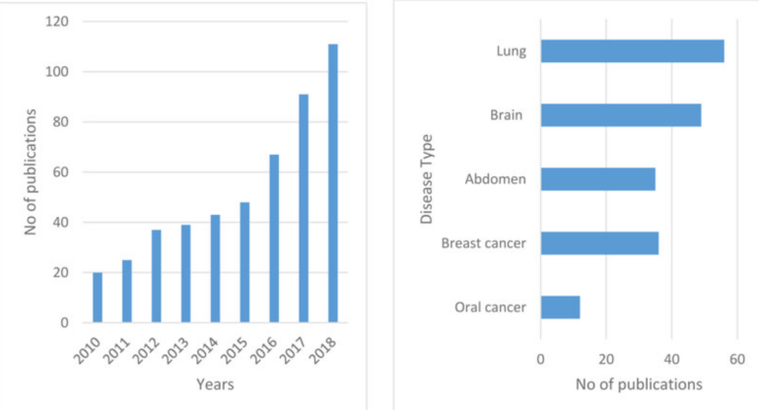

Fig. (1). (a) Publication of papers in oral cancer (b) Publication of papers in different types of cancer in the year 2018.

The combination of heterogeneous data types, such as clinical, imaging, and genomics, may offer adequate information to detect cancerous cells in a patient. The clinical examination permits direct sight of the illness but does not provide an assessment of the disease's depth of penetration. Prior to therapy, cross-sectional testing is becoming the conventional procedure for assessing these tumors. It offers exact information on the breadth and severity of the disease, which may aid pathologists in establishing the most effective care approach and assessing the patient's prognosis. In order to execute the classification tests, the sliced lesion regions were resized based on the previously learned model to the proper input sizes. The cropped images will be used to update the decision tree and XG Boosting techniques used to train the model.

# Literature Review

The researchers wanted to use the less precise results from Naive Bayes, Multilayer Perceptron, KNN, and Support Vector Mechanical to make early-stage oral cancer diagnoses. Classification accuracy is enhanced by the examination of oral cavities [14]. The study's overarching goal is to provide a framework for healthcare providers. Incorporate DATA, NN, and HDM into your high-precision studies, as well as tree-based decision-making techniques and methods for maintaining vectors. Due to its high degree of accuracy and the narrow margin of error, the representation of the ADM's score is the most promising method for diagnosing the recurrence of breast cancer. The findings of the comparison between ANN and DT indicate that SVM is the superior diagnostic method [15]. Madhura V, Meghana Nagaraju, and coworkers conduct a literature study on the use of machine learning in the detection of oral cancer [16]. As a further step, they make use of rules for grouping similar attributes together, and rules for making connections between attributes, to make predictions and prove that attributes are interdependent [17]. To effectively tally things, it uses a breadth-first search and hash, after which it leverages the a priori method to choose frequently occurring item sets and build the association rule from the grutilizingTo acquire precise results in data mining, the researchers use an adaptive fuzzy system built on deep neurons. This approach begins with data analysis and clustering utilising Fuzzy C-Means. An adaptive fuzzy system with deep neurons as its basis has been provided, along with the analytic techniques utilised to produce accurate results in terms of precision, accuracy, and so on [18]. They used experimental data testing and training techniques such as in-depth ANA investigations, transfer studies, and Convolutional Neural networks [19], using data sets that included 251 equatorial X-rays.

The study's goal was to use deep training and Convolutional Neural Network techniques to explore innovative automation approaches for making accurate diagnoses of Oral Squamous Cell Carcinoma from high-quality images. This Convolutional Neural Network is optimized for finding and analyzing quotes, images, training data, and evaluations [20]. Different forms of oral cancer may act in a variety of ways [21]. In recent years, researchers have used a wide variety of machine-learning strategies to combat cancer [22], and machine-learning models are able to identify cancer. Oral cancer risk assessment using machine learning outperforms other methods of risk assessment by a significant margin [23]. Deadly oral cancer has its origins in both the genome [24] and a wide range of pathogenic alterations [25]. The prognosis and treatment of oral cancer at an early stage may improve the likelihood of survival for the patient. Oral cancer is an aggressive and difficult-to-predict illness [27] that requires a combination of machine and deep learning methods. In order to detect oral cancer at an early stage, the researchers present a set of machine-learning algorithms [28] that may be combined. In order to defeat cancer, researchers may utilize a variety of machine learning [29, 30] strategies based on histopathology. Researchers have developed a machine learning-based fusion solution [30] that can accurately detect cancer utilizing real-time data and a variety of neural algorithms. Previous studies employed deep learning techniques in the cloud [31] to defeat cancer and improve therapy, therefore lowering the alarmingly high death rate among women. Through the use of deep learning strategies, cancer may be defeated with the aid of machine learning [32]. Artificial neural networks and deep CNN [34] techniques were utilized on digital pictures [33] to predict cancer, and the results were impressive. Researchers in the COVID phase use machine learning tools to predict cancer in COVID patients [35], achieving extremely efficient results by using a variety of preprocessing strategies. High-feature outcomes may be achieved with the aid of chemoradiotherapy using deep learning radionics-based detections [36].

The study's stated goal was to use in-depth training and Convolutional Neural Network strategies to explore innovative automated approaches for making Oral Squamous Cell Carcinoma diagnoses on clear images. This Convolutional Neural Network was designed with the goals of document retrieval, image analysis, data mining, and classification in mind. Using genetic information and machine learning methods, the researchers were able to forecast which OPL patients will acquire oral cancer. Researchers used a DNN, a Support Vector Machine, a Multi-Layer Perceptron, a minimally invasive treatment, and a history of OPL to study the progression of oral cancer in these patients [37]. In order to categorize the use of hyperspectral to detect lung cancer in the amplification effort, the researcher used ordered electrical machines. Utilizing a Convolutional Neural Network, they segmented the information into visual representations. Due to the absence of a standalone cancer detection system design, extensive research methods were used to fill the void [38].

Most methods need elaborate system setup, which may be time-consuming and costly to maintain. Several methods of cancer diagnosis were evaluated, and the advantages of symptom simulations were spelled out. Thus, HSI may be used for data categorization. The data is classified using a vector support machine with a self-mapping structure [39].

# Methodology

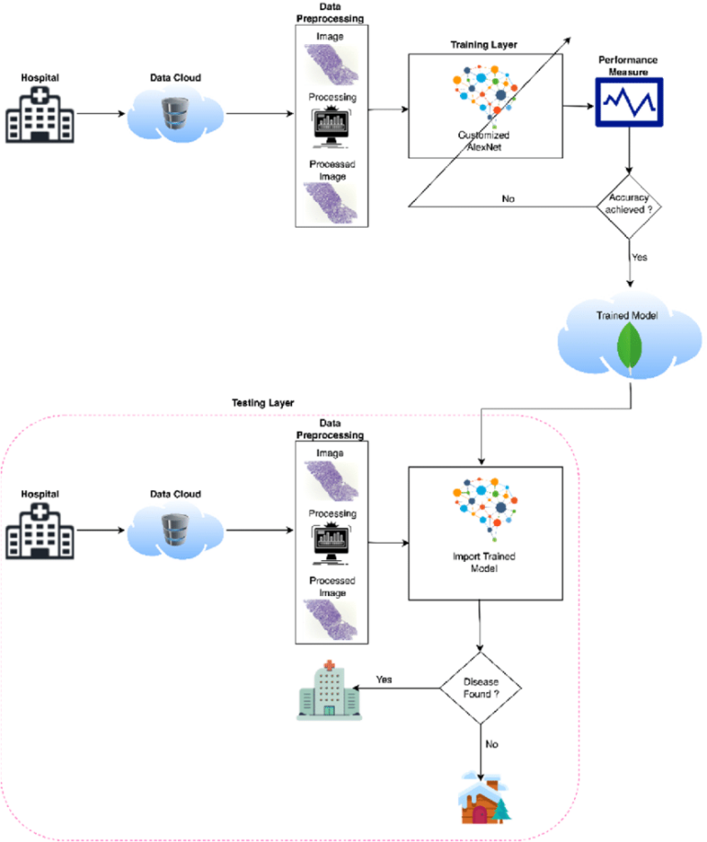

## *Datasets*

2500 photos with oral cancer and 2500 images without cancer were included in the oral cancer histopathology imaging databases.

It features photos of the lips and tongue that are divided into two categories: malignant and non-cancerous cells. This is an issue of binary classification.

The photos in our sample had a median width and height of 546 and 397 pixels, respectively, and a median width and height of 397 pixels.

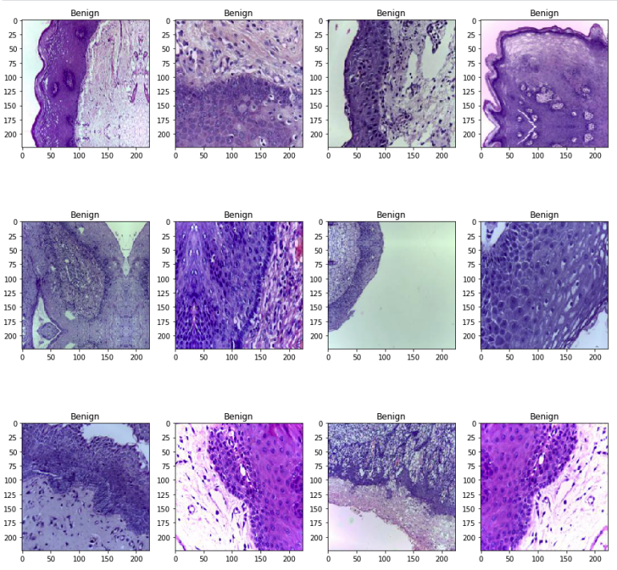

Fig 2. Dataset Sample

## *Data Preparation*

A vital phase in the work of a Machine Learning Engineer is the pre-processing or purification of data, and the vast majority of Machine Learning Engineers dedicated considerable effort before developing a model from scratch. Outlier detection, missing value treatment, and the removal of undesired or noisy data are just a few examples of data pre-processing techniques.

Images at the lowest level of abstraction are referred to as image pre-processing, which is the same as image processing. According to entropy as an information metric, these processes do not increase image information content, but rather decrease it. In pre-processing, the goal is to make the image data better by suppressing unwanted distortions and enhancing some visual properties that are important for the task of subsequent processing and analysis after it has been captured.

Several pre-processing procedures must be performed on the input data before it can be used. These procedures may comprise the following steps:

1. Formatting & Resizing
2. Enhancement
3. Region of Interest (ROI) Extraction
4. Data balancing

*C. Modeling*

The model was developed using a Decision Tree and XG Boosting techniques. In the following step, the proposed model was tested against the test dataset.

|  |
| --- |
| 1 Start |
| 2 Input Oral Cancer Data from Data Cloud |
| 3 Pre-process Oral Cancer data |
| 4 Load Data |
| 5 Load Customized Model |
| 6 Prediction of Oral Cancer using Machine Learning Learning (AlexNet) |
| 7 Training Phase |
| 8 Image Testing Phase |
| 9 Compute the Performance and Accuracy of the proposed  model by using the Performance Matrix |
| 10 Finish |

Table 1. Pseudocode of the proposed model for oral cancer prediction.

**I. XG Boosting**

XGBoost is a decision-tree-based ensemble Machine Learning method that makes use of a gradient-boosting framework in order to enhance accuracy and speed. XGBoost was developed by Microsoft Research and is named after the company's founder. In prediction problems involving unstructured data (pictures, text, and so on), the performance of artificial neural networks tends to outperform that of every other algorithm or framework. However, decision tree-based algorithms are regarded as the most effective method for handling small to medium-sized structured or tabular data sets.

Both XGBoost and Gradient Boosting Machines (GBMs) are examples of ensemble tree methods. These ensemble tree methods both make use of the gradient descent architecture to apply the principle of boosting weak learners (in general, CARTs) in order to enhance their performance. People and teams have become particularly fond of XGBoost because it has helped them win nearly every Kaggle structured data competition. Competitors in these competitions post data, and statisticians and data miners compete to create the best models for predicting and explaining the data. XGBoost was first implemented in Python and then in R. Today, XGBoost includes package implementations for Java, Scala, Julia, Perl, and other languages as a result of its widespread adoption. It has become increasingly popular in the Kaggle community as a result of these new XGBoost implementations.

A wide range of other tools and packages, including scikit-learn for Python and caret for R users, have been integrated with XGBoost. Distributed processing frameworks such as Apache Spark and Dask can also be used with XGBoost thanks to its integration. This year, InfoWorld honored XGBoost with its prestigious Technology of the Year award, which it won with flying colors.

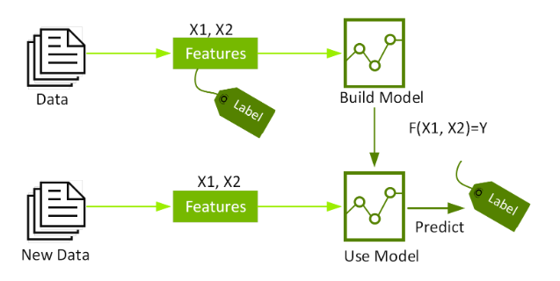

Fig 3.XG Booting Flow

As a machine learning classifier, we employ XGboosting, which is based on the ensemble technique. XGBoost is a fast and efficient implementation of gradient-boosted decision trees that are optimized for performance. The algorithm's implementation was designed to be as efficient as possible in terms of computing time and memory resources. One of the design goals was to make the best possible use of the resources available to train the model.

**II. Decision Tree**

Decision Trees are a sort of Supervised Machine Learning (in which you describe what the input data is and what the associated output data is in the training data) in which the data is continually separated according to a specific parameter, as opposed to unsupervised machine learning. Two entities, namely decision nodes, and leaves, can be used to explain the structure of the tree. The decisions or final outcomes are represented by the leaves. And the decision nodes are the points at which the data is divided.

A Decision Tree is a Supervised learning technique that may be used to solve classification and regression problems. However, it is most commonly used to solve classification problems. There are two nodes in a decision tree, which are referred to as the Decision Node and the Leaf Node. In contrast to Decision nodes, which are used to make any decision and have numerous branches, Leaf nodes are the result of such decisions and do not contain any more branches.

In this case, the judgments or tests are carried out on the basis of the characteristics of the dataset. In computing all possible solutions to a problem or decision based on specified conditions, it is useful to use graphs to describe the information. This structure is known as a decision tree because, like a tree, it begins with the root node and then develops on subsequent branches to form a tree-like structure.

We employ the CART method, which stands for Classification and Regression Tree algorithm, in order to construct a tree of knowledge. A decision tree is a simple structure that asks a question and then divides the tree into subtrees based on the answer (yes or no).

The general structure of a decision tree is illustrated in the diagram below:

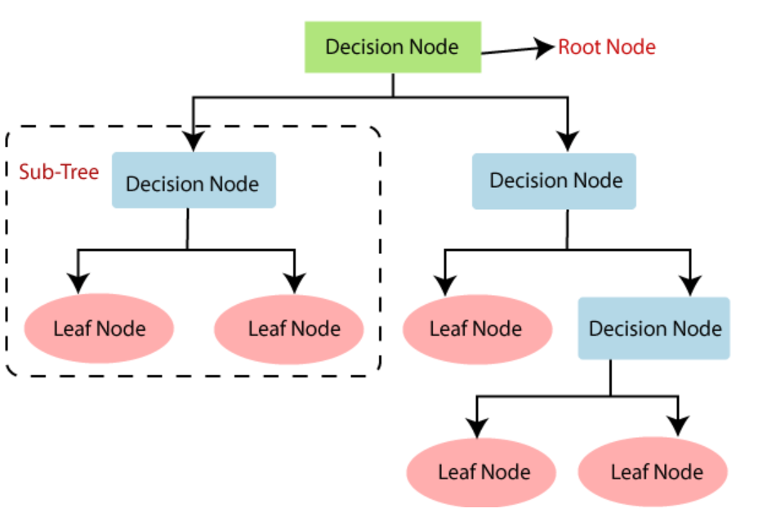

Fig 4. Decision tree classification algorithm

It is necessary to isolate lesion sites because oral lesions are frequently obscured by structures such as teeth and dental instruments and because some images contain numerous lesions of different classifications.

During the segmentation and detection studies, the images were shrunk to around 100 pixels along the longest image dimension. In order to conduct the classification tests, the cropped lesion areas were resized to the appropriate input sizes based on the previously trained model. The cropped photos will be used to update the decision tree algorithm, which will then be used to train the new model.

## *D. Validation Method*

We validated the performance of models with 120 images, including an equal number of instances from both classes. The test dataset contained images with both 100x and 400x magnification. Moreover, The train/test split was performed before the augmentation, which means the test dataset contained original images.

To evaluate the performance, we calculated accuracy, precision, Recall, F1-score, specificity, and AUC value for each model. These statistical metrics are based on True Positives (TP), False Negatives (FN), False Positives (FP), and True Negatives (TN). Here, TP and TN represent the number of correctly identified cancerous and normal images, while FP and FN denote misclassified normal and cancerous images, respectively.

This statistic describes how well the model performs across all classes and is used to evaluate its accuracy. It is useful when all of the classes are of similar significance to the student. Heuristics are used to calculate this as the ratio of correct guesses to the total number of forecasts. The accuracy of a data set is defined as the proportion of correctly classified data instances to the total number of data sets.

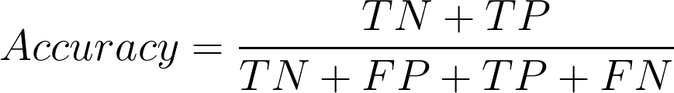

If the dataset is not balanced, accuracy may not be a useful metric to use (both negative and positive classes have different numbers of data instances).

# Results

It was necessary to verify the acquired result and model in multiple photos in order to evaluate the proposed approach. Malignant tumors are distinguished from benign tumors in their classification. It was discovered that the proposed decision tree had an accuracy of 59 percent. and the suggested XG Boosting was found to be accurate to within 64%.

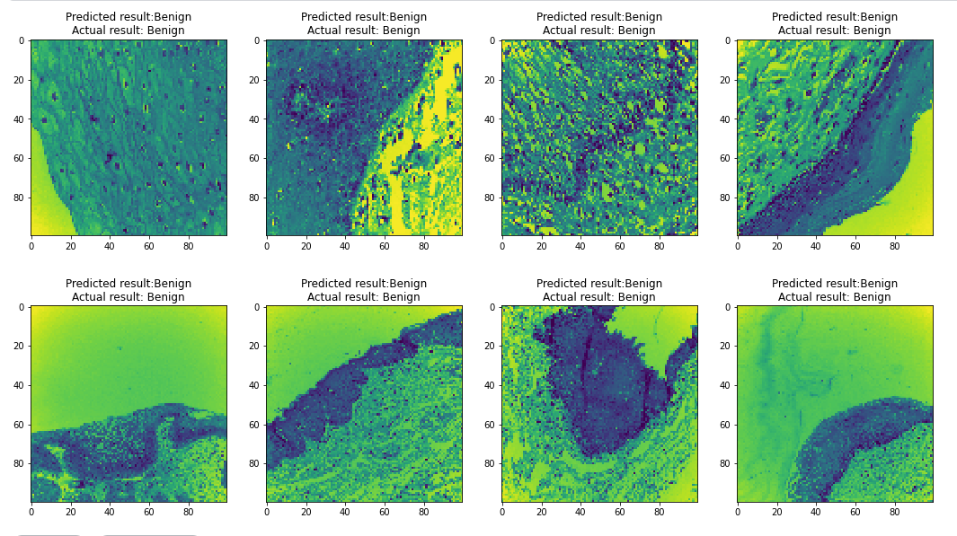

Fig 5a. Decision tree model Accuracy

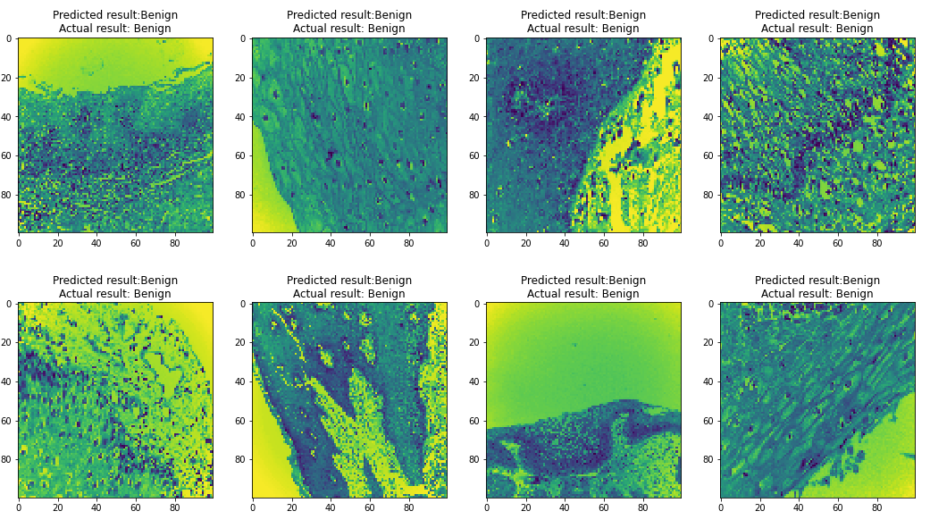

Fig 5b. XG Boosting model performance

# Conclusion and future work

As part of this research, we created a machine-learning algorithm for an autonomous cancer diagnostic system. They present the features of hyperspectral medical images of oral cancer case studies that were investigated. The stochastic neighbor embedding method was also used to graphically represent the elements of the hyperspectral image that were under investigation. According to this algorithm, 66 percent of the results are accurate.

Additionally, they demonstrate an increase in accuracy of 4.5 percent when a significant number of cancer subject data sets are used for the training phase, resulting in 500 picture datasets being obtained. As a result, the processing system correctly predicted whether the tumor was a malignant tumor or a benign tumor in this analysis.

To improve the accuracy of the model, we must employ a deep learning-based way of training the model. When employing a pretrained model, image categorization outperforms when using a trained model.

# References

1. Hanahan D, Weinberg RA. Hallmarks of cancer: the next generation. Cell 2011; 144(5): 646-74.
2. Leung F, Eberlin LS, Schwamborn K, Heeren RMA, Winograd N, Cooks RG. Mass spectrometry-based tissue imaging: the next frontier in clinical diagnostics? Clin Chem 2019; 65(4): 510-3.
3. Ifa DR, Eberlin LS. Ambient ionization mass spectrometry for cancer diagnosis and surgical margin evaluation. Clin Chem 2016; 62(1): 111-23.
4. Porcari AM, Zhang J, Garza KY, et al. Multicenter study using desorption-electrospray-ionization-mass-spectrometry imaging for breast-cancer diagnosis. Anal Chem 2018; 90(19): 11324-32.
5. Tata A, Gribble A, Ventura M, et al. Wide-field tissue polarimetry allows efficient localized mass spectrometry imaging of biological tissues. Chem Sci (Camb) 2016; 7(3): 2162-9.
6. Woolman M, Tata A, Bluemke E, Dara D, Ginsberg HJ, Zarrine-Afsar A. An assessment of the utility of tissue smears in rapid cancer profiling with desorption electrospray ionization mass spectrometry (DESI-MS). J Am Soc Mass Spectrom 2017; 28(1): 145-53.
7. Tata A, Woolman M, Ventura M, et al. Rapid detection of necrosis in breast cancer with desorption electrospray ionization mass spectrometry. Sci Rep 2016; 6: 35374.
8. Ristevski B, Chen M. Big data analytics in medicine and healthcare. J Integr Bioinform 2018; 15(3)
9. Gurcan MN, Boucheron LE, Can A, Madabhushi A, Rajpoot NM, Yener B. Histopathological image analysis: a review. IEEE Rev Biomed Eng 2009; 2: 147-71.
10. Onder D, Sarioglu S, Karacali B. Automated labelling of cancer textures in colorectal histopathology slides using quasi-supervised learning. Micron 2013; 47: 33-42.
11. Unsupervised segmentation and classification of cervical cell images. Pattern Recognit 2012; 45(12): 4151-68.
12. Ojansivu V, Linder N, Rahtu E, et al. Automated classification of breast cancer morphology in histopathological images. Diagn Pathol 2013; 8(1): S29.
13. Patel JL, Goyal RK. Applications of artificial neural networks in medical science. Curr Clin Pharmacol 2007; 2(3): 217-26.
14. Cireşan DC, Giusti A, Gambardella LM, Schmidhuber J. Mitosis detection in breast cancer histology images with deep neural networks. International Conference on Medical Image Computing and Computer-assisted Intervention 411-8.
15. Zhuo L, Jiang L, Zhu Z, Li J, Zhang J, Long H. Vehicle classification for large-scale traffic surveillance videos using convolutional neural networks. Mach Vis Appl 2017; 28(7): 793-802.
16. Lim LAG, Maguib RN, Dadios EP, Avila JMC. Implementation of GA-KSOM and ANFIS in the classification of colonic histopathological imagesTENCON 2012 IEEE Region 10 Conference 2012; 1-5.
17. Li C, Zhang S, Zhang H, et al. Using the K-nearest neighbor algorithm for the classification of lymph node metastasis in gastric cancer. Comput Math Methods Med 2012; 2012876545
18. Chen G, Zhang J, Zhuo D, Pan Y, Pang C. Identification of pulmonary nodules via CT images with hierarchical fully convolutional networks. Med Biol Eng Comput 2019; 57(7): 1567-80.
19. Sertel O, Kong J, Shimada H, Catalyurek UV, Saltz JH, Gurcan MN. Computer-aided prognosis of neuroblastoma on whole-slide images: Classification of stromal development. Pattern Recognit 2009; 42(6): 1093-103.
20. Tseng CJ, Lu CJ, Chang CC, Chen GD. Application of machine learning to predict the recurrence-proneness for cervical cancer. Neural Comput Appl 2014; 24(6): 1311-6.
21. Stojadinovic A, Nissan A, Eberhardt J, Chua TC, Pelz JO, Esquivel J. Development of a Bayesian Belief Network Model for personalized prognostic risk assessment in colon carcinomatosis. Am Surg 2011; 77(2): 221-30.
22. 22. Sun, M.-L.; Liu, Y.; Liu, G.-M.; Cui, D.; Heidari, A.A.; Jia, W.-Y.; Ji, X.; Chen, H.-L.; Luo, Y.-G. Application of Machine Learning to Stomatology: A Comprehensive Review. IEEE Access 2020, 8, 184360–184374. [CrossRef]
23. Alkhadar, H.; Macluskey, M.; White, S.; Ellis, I.; Gardner, A. Comparison of machine learning algorithms for the prediction of five-year survival in oral squamous cell carcinoma. J. Oral Pathol. Med. 2021, 50, 378–384. [CrossRef]
24. Saba, T. Recent advancement in cancer detection using machine learning: Systematic survey of decades, comparisons and challenges. J. Infect. Public Health 2020, 13, 1274–1289. [CrossRef]
25. Kouznetsova, V.L.; Li, J.; Romm, E.; Tsigelny, I.F. Finding distinctions between oral cancer and periodontitis using saliva metabolites and machine learning. Oral Dis. 2021, 27, 484–493. [CrossRef] [PubMed]
26. Alhazmi, A.; Alhazmi, Y.; Makrami, A.; Salawi, N.; Masmali, K.; Patil, S. Application of artificial intelligence and machine learning for prediction of oral cancer risk. J. Oral Pathol. Med. 2021, 50, 444–450. [CrossRef] [PubMed]
27. Chu, C.S.; Lee, N.P.; Adeoye, J.; Thomson, P.; Choi, S.W. Machine learning and treatment outcome prediction for oral cancer. J. Oral Pathol. Med. 2020, 49, 977–985. [CrossRef] [PubMed]
28. Welikala, R.A.; Remagnino, P.; Lim, J.H.; Chan, C.S.; Rajendran, S.; Kallarakkal, T.G.; Zain, R.B.; Jayasinghe, R.D.; Rimal, J.; Kerr, A.R.; et al. Automated Detection and Classification of Oral Lesions Using Deep Learning for Early Detection of Oral Cancer. IEEE Access 2020, 8, 132677–132693. [CrossRef]
29. Mehmood, S.; Ghazal, T.M.; Khan, M.A.; Zubair, M.; Naseem, M.T.; Faiz, T.; Ahmad, M. Malignancy Detection in Lung and Colon Histopathology Images Using Transfer Learning with Class Selective Image Processing. IEEE Access 2022, 10, 25657–25668. [CrossRef]
30. Ahmed, U.; Issa, G.F.; Khan, M.A.; Aftab, S.; Said, R.A.T.; Ghazal, T.M.; Ahmad, M. Prediction of Diabetes Empowered with Fused Machine Learning. IEEE Access 2022, 10, 8529–8538. [CrossRef]
31. Siddiqui, S.Y.; Haider, A.; Ghazal, T.M.; Khan, M.A.; Naseer, I.; Abbas, S.; Rahman, M.; Khan, J.A.; Ahmad, M.; Hasan, M.K.; et al. IoMT Cloud-Based Intelligent Prediction of Breast Cancer Stages Empowered with Deep Learning. IEEE Access 2021, 9, 146478–146491. [CrossRef]
32. Sikandar, M.; Sohail, R.; Saeed, Y.; Zeb, A.; Zareei, M.; Khan, M.A.; Khan, A.; Aldosary, A.; Mohamed, E.M. Analysis for Disease Gene Association Using Machine Learning. IEEE Access 2020, 8, 160616–160626. [CrossRef]
33. Kuntz, S.; Krieghoff-Henning, E.; Kather, J.N.; Jutzi, T.; Höhn, J.; Kiehl, L.; Hekler, A.; Alwers, E. Gastrointestinal cancer classification and prognostication from histology using deep learning: Systematic review. Eur. J. Cancer 2021, 155, 200–215. [CrossRef]
34. Heuvelmans, M.A.; Ooijen, P.M.A.; Sarim, A.; Silva, C.F.; Han, D.; Heussel, C.P.; Hickes, W.; Kauczor, H.-U.; Novotny, P.; Peschl, H.; et al. Lung cancer prediction by Deep Learning to identify benign lung nodules. Lung Cancer 2021, 154, 1–4. [CrossRef]
35. Ibrahim, D.M.; Elshennawy, N.M.; Sarhan, A.M. Deep-chest: Multi-classification deep learning model for diagnosing COVID-19, pneumonia, and lung cancer chest diseases. Comput. Biol. Med. 2021, 132, 104348. [CrossRef] [PubMed]
36. Liu, X.; Zhang, D.; Liu, Z.; Li, Z.; Xie, P.; Sun, K.; Wei, W.; Dai, W.; Tang, Z. Deep learning radiomics-based prediction of distant metastasis in patients with locally advanced rectal cancer after neoadjuvant chemoradiotherapy: A multicentre study. EBio Med. 2021, 69, 103442. [CrossRef] [PubMed]
37. Wafaa Shams, K.; Zaw, Z. Oral Cancer Prediction Using Gene Expression Profiling and Machine Learning. Int. J. Appl. Eng. Res. 2017, 12, 0973–4562.
38. Kalantari, N.; Ramamoorthi, R. Deep high dynamic range imaging of dynamic scenes. ACM Trans. Graph. 2017, 36, 144:1–144:12. [CrossRef]
39. Deepak Kumar, J.; Surendra Bilouhan, D.; Kumar, R.C. An approach for hyperspectral image classification by optimizing SVM using self-organizing map. J. Comput. Sci. 2018, 25, 252–259